January 2023
TechAdmin Report

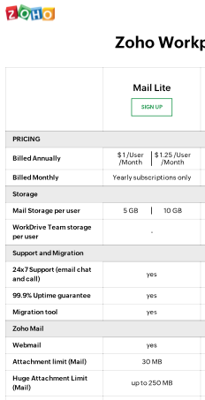
The District can get 6 email addresses – the same number of offices – with a slightly expanded level of service for just under $100/year.
Detail—

As mentioned in the Full chart (attached),
- It is not possible to mix free and paid plans. However, one can mix and match users in different paid plans.
- Nonetheless, attachment size limits apply to both sending and receiving, so large attachments cannot be shared unless both users have similar size limits, and the largest attachments are split over more than one message.
Therefore, the attachment and storage limits indicate it could be best for all 6 accounts to be identical. Otherwise some accounts could be shared, reducing the number.

